Curriculum Overview
Key Stage 3
Curriculum Intent:
Through our curriculum we aim to reengage learners with education and, where possible, successfully transition back into mainstream education. By providing opportunities for success, we challenge excluded young people to exceed their own expectations and instil confidence and resilience. We intend to keep our young people safe by empowering them with knowledge of the wider world so they are better equipped to make informed choices.

Implementation:
Topics taught in PSHE are ‘spiral’ and developmental. The aim is that knowledge and understanding is built upon through the academic key stages whilst also looking to make cross curricular links, where possible and appropriate. Topics are aimed at the developmental stage of students and are revised regularly to ensure they are suitable for our students. Lessons are to be delivered by staff who feel confident and prepared to do so during timetabled lessons dedicated tutor times. Staff will have the flexibility to deviate from curriculum plans to address behaviour, safeguarding or social issues. This will be reviewed during departmental meetings.

Impact
The curriculum is structured so learners to access preventative education that will support future transitions. Learners gain knowledge, language and skills that are valued by their local, and wider, communities and are resilient enough to receive challenge, accept other people’s points of view and advocate for their own needs.

.

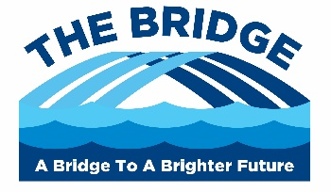

Core Theme 1 – Health & Wellbeing
This Core Theme covers mental, physical and emotional wellbeing. Enriching understanding of what mental ill health can look like, healthy coping mechanisms that can be used to manage mental ill health and how to promote positive mental wellbeing in yourself and others. The topics developed further into looking at the links between physical and mental health and the impacts this can have on emotional wellbeing in the now and in the future.

Core Theme 2 - Relationships
This Core Theme covers the development of healthy relationships and incorporates the statutory requirements of Sex and Relationships Education. The topic explores how to build healthy relationships with family and peers before looking at romantic relationships, consent, contraception/pregnancy choices and development of the family unit. The aim is to equip students with knowledge to make informed choices, behave in a respectful and appropriate manner and understand the law around Sex, Relationships and Media.

Core Theme 3 – Living in the Wider World
This Core Theme covers the development of students as part of their wider community. Developing awareness global issues, different cultures and of how developmental stages can influence personal change, students look to enhance their understanding of broader topics and gain practical and useful understanding of topics covered to develop healthy discussion, make informed and appropriate decisions and contribute positively to their local and wider community.

